

Project Title

Music Genre Classification
  - Problem Statement
With the growth of digital music platforms like Spotify and Apple Music, automatically identifying the genre of a song has become very important. ‘Music Genre Classification’ helps improve music recommendations, organize large music libraries, and support streaming algorithms.
  - Dataset Description
We have used pre-processed GTZAN dataset, specifically the features_3_sec.csv file from Kaggle (https://www.kaggle.com/datasets/andradaolteanu/gtzan-dataset-music-genre-classification/data). This dataset contains audio features extracted from 3-second segments of the original audio files. Since this data is pre-processed, including normalization, we have not performed additional normalization steps in this notebook.
Methodology
Approach
We have followed these main steps in the project:
Feature Extraction: The features_3_sec.csv file already contains the extracted features, so we will be loading and utilizing these pre-computed features. These include:
  - MFCCs (Mel-Frequency Cepstral Coefficients)
  - Mel Spectrograms
  - Chroma Features
  - Spectral Centroid, Bandwidth, and Zero-Crossing Rate
Model Development: We have used the extracted features to train machine learning models for genre classification. XGBoost (Extreme Gradient Boosting) and Random Forest are powerful algorithms we will utilize.
- Evaluation: Evaluate the model using metrics like accuracy, confusion matrix, precision, and F1-score to assess its performance in classifying between 'rock' and 'hiphop' genres.

Algorithm
XGBoost for genre classification
KNN for music recommendation
  - Experimental Details:
    - Architecture Description:
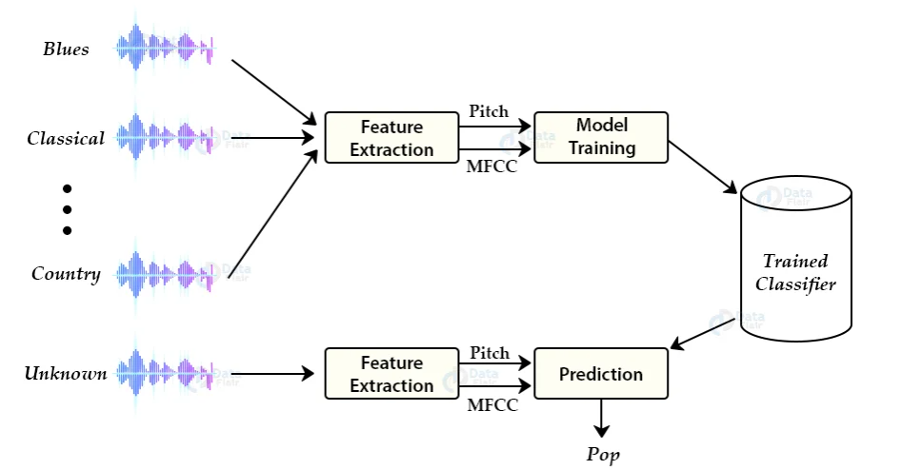
    - Evaluation Metrics:
- Accuracy, confusion matrix, precision, F1-score
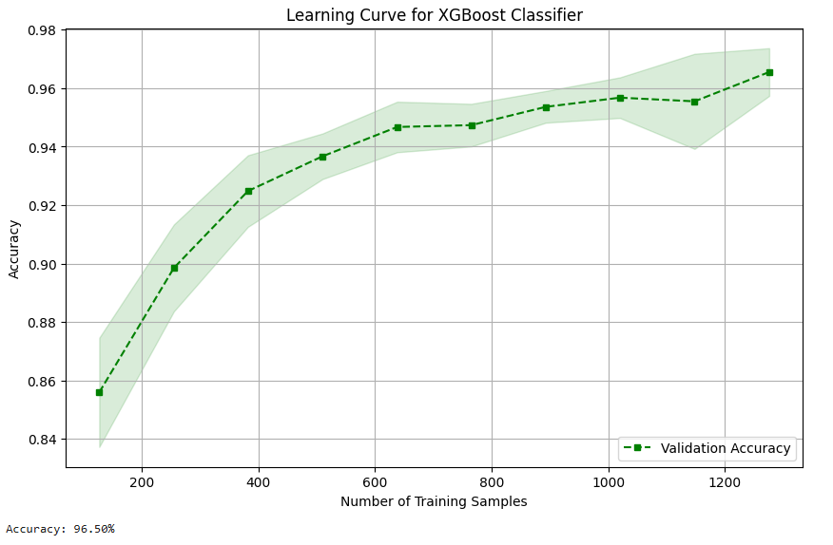
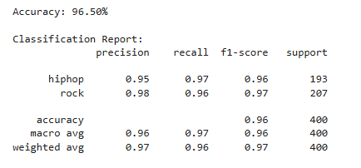
- Train/test split and cross-validation
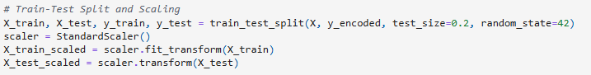
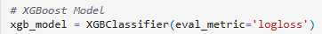
eval_metric='logloss' indicates that logarithmic loss will be used for evaluation
    - Dataset Split: Data used for training, validation, and testing -80 % and 20 %

  - Results and Discussion:
    - Results:

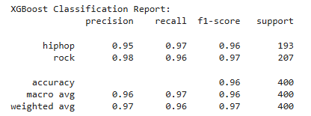
.

    - Visualizations:
